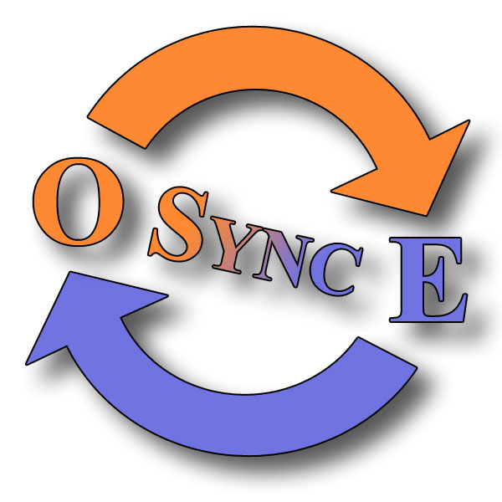
eGWOSync
an eGroupware/Outlook Sync tool.

MiniGuide
Manual for Version 0.4.0
Last edited Sunday, 12 March 2006

Introduction 4
This MiniGuide 4
What eGWOSync is 4
What eGWOSync is not 4
History 4
Features 5
License 5
Contributors and Credits 5
Setup 6
System Requirements 6
Client side 6
Server Side 6
Getting the Software 6
Installing the Software 6
Uninstall the Software 6
Configuration 7
First Time Guide 7
eGWOSync Settings 7
Generals Tab 7
Show on startup 7
Startup Guide 7
New Version Check 7
Sync Tab 8
Before Deletion 8
Before Overwrite 8
Check Server Time 8
Save SyncDB for each update 8
Host/User Tab 9
Host Information 9
User Information 9
Test Login 9
Logging Tab 10
Log Level 10
XML Log 10
Utilities Tab 11
Enable Utilities 11
XML Database Consistense Check 11
Check for Doublets in Outlook Folder 11
Using eGWOSync 12
Outlook Warnings 12
Tray Icon 12
Sync Calendar/Addressbook/Notes/Todo’s 12
Troubleshooting 13
Known bugs/Issues 13
TCPTrace 13
Huh, it does what? 13
Looking Into the XML Log 14
Getting Help 15
Mailinglists 15
E-mail 16
FAQ 16
Appendix A 17
The GNU General Public License (GPL) 17

Introduction

This MiniGuide
I have written this MiniGuide, to help users get a quick way to get it up and running. I hope this will help towards a positive attitude to eGWOSync, eGroupware and OpenSource in general. I also believe that a lot of OpenSource projects lack in documentations, as this is for a programmer the boring part of creating a program.

Please feel free to write addition to this miniguide, or email me comments for sections you feel that is needed.

What eGWOSync is

eGWOSync is a synchronization tool between Outlook and eGroupware (eGW). Currently it syncs calendar, contacts, notes and todo’s. Because it a sync tool it means that you can sync your calendar in the morning and take you laptop offline for the day work on it and when you get online again you can sync the changes to either eGroupware or Outlook. It used to be intergraded into Outlook but I have decided to make it an external tool witch means that you can sync your Outlook without having it started.

What eGWOSync is not

eGWOSync is not an Exchange client clone, which means that the data you change in Outlook is only changed there until next sync with eGroupware. The same goes of cause the other way around. This means that you have to have a local .pst file on your computer. eGWOSync cant also not open other users folder in eGroupware.

History

It started when Chris Carter started building the first block for a sync tool with the xml-rpc module from Enappsys. Then Ian Smith-Heisters made a draft of contacts sync in VBA (Visual Basic for Applications). By the time I joined the team, Chris has stopped cos he didn't have time. I transferred the code into VB and created the COM Add-In witch we use today.
Now Ian has also resigned from the project, regrettably, and it’s only I who is left. About November 2004 I started the calendar sync module with significant changes to the way it communicates with the eGW server. I decided not to include the contact sync into my code, cos the very different way it works. After 2 releases, I decided that the Enappsys xmlrpc interface was too bad and slow. Around August 2005 I started migrating the code into vb.NET and changed the xmlrpc interface to xmlrpc.net (www.xml-rpc.net). It quickly showed that it was a larger task than first though. It has been almost a complete rewrite of the underlying engine, and the GUI did also get a huge upgrade. In Jan. 2006 I released version 0.3 with calendar and contact sync using the .NET version. Now in Marts 2006 I have just released the version 0.4 witch also supports notes and todo’s. In addition I have also enabled SSL support for (trusted sites only).

Features
The current features for eGWOSync are:
- Synchronize calendar, contacts, notes and todo items
- Standart HTTP and HTTPS support
- Debug, Info, Warnings, Critical and No Logging.
- Utilities for xml db and Outlook doublets.

License

eGWOSync is licensed by Esben Laursen (hyber@hyber.dk) under GNU GPL Ver. 2 or later. See the whole license in appendix A

Contributors and Credits
I would like to thank the following people for helping directly or indirectly.

- Chris Carter - for starting this whole process by building the first blocks.
- Ian Smith-Heisters - for his great great job in the contacts sync.
- Miles Lott - for helping with eGW code.
- Ralf Becker - for adding features into eGroupware xmlrpc interface, his great help debugging the xml code and fixing bug in eGW
- The whole eGroupware Developer teem.

Setup

System Requirements
There are not many system requirements, but there is some that you need to obey.

Client side
On you client you will need at least
- Microsoft .NET 1.1 framework. (download it from windowsupdate.microsoft.com)
- Microsoft Windows 95/98/NT/2k/XP (2000 and XP is recommended)
- Microsoft Outlook XP/2003
- eGWOSync 0.4.0 :-)

It has only been tested with Windows 2000 and Outlook XP, although I haven’t used any technology not available in older or newer versions :-)

Server Side
On you server you need at least.
- eGroupWare 1.2RC7 (1.2.007) with an enabled xmlrpc interface

Getting the Software
Currently eGWOSync is only available from www.hyber.dk later it properly will be included into eGroupware download site at SourceForge, or it will have its own projects page at SourceForge. The updates in webpage’s will announced on www.hyber.dk, so go there for updates.

Installing the Software
To install eGWOSync, Download the installer, and double click on it. Then the nice VB installer will lunch, and help you install it.
The installer greats you. Say thanks, and click on next button. Then you have to accept the license agreement and decide where you want to install it. Normally it should be in the program files folder, but you can decide for your self if you want. When you have selected (or just want the default location) click next, and it will proceed into copying the files to your computer.

After its done copying the files, just click close and the installer program will exit. Now go into start → programs → eGroupware’s eGWOSync folder and open eGWOSync.

Uninstall the Software
To uninstall eGWOSync just go to your control panel and select “add/remove programs” Find eGWOSync and select remove. That’s it.

Configuration

First Time Guide
The first time you run eGWOSync on you computer, it will display the “First Time Guide” to help you quickly getting started syncing your Outlook and eGroupware. The guide will only setup the most basic settings like host and username. Therefore it’s a good idea to look into the settings pages, as extra logging feature and such is available from there.

eGWOSync Settings
The eGWOSync settings, is divided into pages, each containing each special fields, currently there is General, Host/User and Logging pages. More may come later.

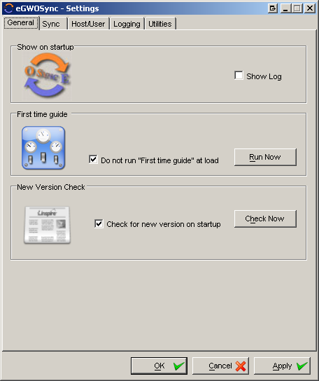
Generals Tab
The generals tab is where all settings that don’t fit anywhere else will be.

Show on startup it allow you to choose witch screens to display on loads. As default it shows the main sync windows.

Startup Guide It’s where you can those to (re)run the First Time Guide, either on next start up, immediately or not at all.

New Version Check this will simply just check against
egwosync.hyber.dk/egwosyncver.txt to see if there is a new version available. No information about your system is send :-)

Sync Tab
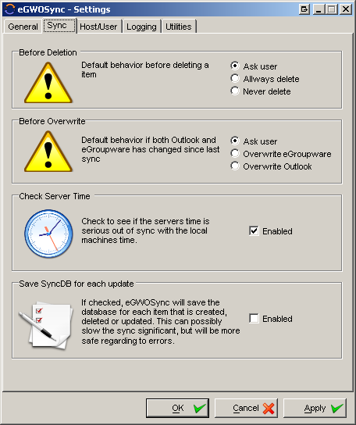
Before Deletion is as I like to call it: the last defence for eGWOSync to delete your calendar or contacts. As default it will prompt you before complete deleting anything in either Outlook or eGroupware. You can choose (if you trust you program and yourself) to automatically delete or never to delete. This security measure will of cause only occur if a item has been deleted by you in either Outlook or eGroupware.

Before Overwrite this will by default ask you what to do if both the eGroupware and Outlook item has changed since last sync. If only one item has been changed since last sync it will automatically update the oldest one, no questions asked. You can then either (as default) choose from item to item or choose to always keep the eGroupware or Outlook item.

Check Server Time this will query eGroupware for its local time, and compare it with the client machine local time. It will then calculate the offset between client and server and use that to sync correctly. This does only work if the client and server are in the date. If they are not in the same date it will exit with an error.
You can disable the offset function by changing the “<UseServerTimeOffset>” to false in the settings.xml file under your profile.

Save SyncDB for each update this will make sure that if an error happens and the sync stops, then the database or rather the xml file with the sync information is up to date. It will for each item it adds, deletes or updates save the xml file. If its disabled the database will only be save after a successful sync. When enabled it could possibly slow your sync down significant if you sync database it very large and you update a lot of items in either Outlook or eGroupware. Default setting is disabled.

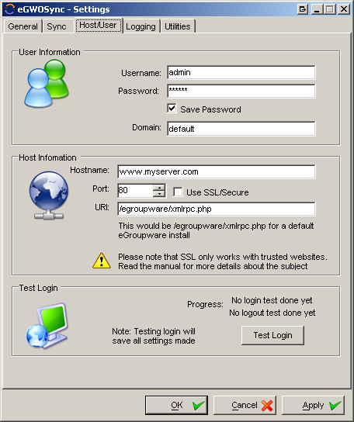
Host/User Tab
This is where you set all the information about the eGroupware server, the paths to the xmlrpc interface within eGroupware and all the user information’s. The username/passwords textboxes gives pretty much it self, but please notice that if you choose to save the password, it will be stored in the xml settings file under your profile as clear text.

Host Information The Hostname textbox is for the either the hostname or the IP address. You shouldn’t use http:// in front of the hostname. If you want to use SSL then be sure that it’s a trusted website or it will not work. If the website is not trusted you sould import the digital certificate. For it to work you should be able to browse into the site with a internet explorer and _not_ see any warnings about untrusted certificate, if you do it will not work. The port will normally be 80 (443 for SSL), but for instance if you are using TCPTrace it could be 8080.
URI or “Uniform Resource Identifier” is the path to eGroupwares xmlrpc.php page. It will in a standard installation of eGroupware be /egroupware/xmlrpc.php

User Information I guess there isn’t anyone who don’t know what that’s for. The only thing I think you should know is that the password is currently stored in the registry as clear text.

Test Login When you have entered all the information needed, you can try to do a test login. If it succeed, then it’s all beautiful if not the double check the information entered, and if you are sure that its correct try the troubleshooting pages later in this miniguide.

Logging Tab
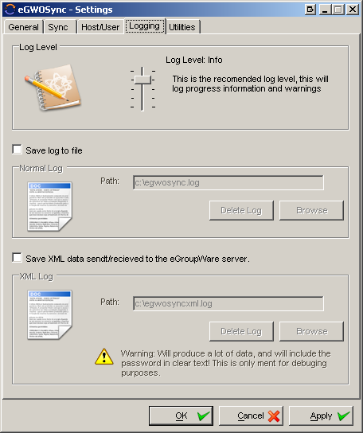
The logging tab, is where you can define how you want your logging to act. eGWOSync has two different log files; one for the normal log and one for debugging, where all the xml data sent back and fourth.

Log Level There are 5 different log levels; None, Critical, Warnings, Info and Debug.

Debug will log a lot of data, from both eGWOSync and the underlying engine. This is mostly for debugging purposes as it can indicate where a error happens.
Info is the recommended logging level, it will log the progress of the sync in a form that is easy to understand and overview.

Warnings will only log if there is a possible problem, but not necessarily a problem

Critical will only log absolute critical problems where the sync can’t proceed and you have to check your Outlook and eGroupware for inconsistence

None will of cause not log anything.

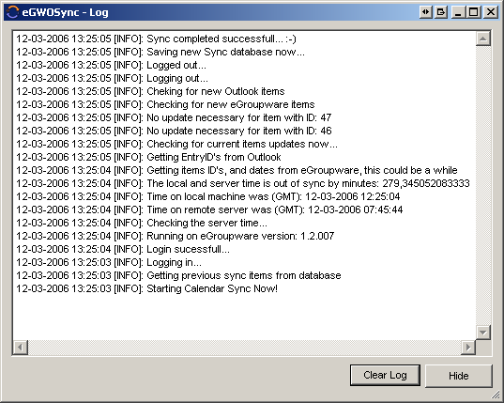
Save log to file If enabled it will save the log information to your hard drive. This is the ser-friendly information (see Error: Reference source not found), like “Sync is started” or “Logging in..” and such. It should be pretty simple for users to understand it. No matter if the “Save log to file” is selected or not, there will be logged into the eGWOSync log window. It will just not be saved into the hard drive. If some degree of debugging is necessary it’s possible to crank up the log level to see debug information or perhaps lowering it only to see warnings..

XML Log The XML logging is not like the Normal Log, it can not be shown from within the program. It’s solely for debugging purposes. To understand it it’s necessary to understand how XML works and how eGWOSync communicate with eGroupware. I have added the functionality because, is often necessary to see the dataflow to understand if it is the eGroupware server or eGWOSync that make the error. When it’s running normal it’s highly recommended that XML logging is disabled, as it stores a lot of data, including you username, password and hostname. If you use a public computer please make sure to delete the log before you leave the computer. If you decide to share the XML log, please make sure to remove any sensitive information from there. Or any user that gets hold of you log can login with the information provided!

Utilities Tab

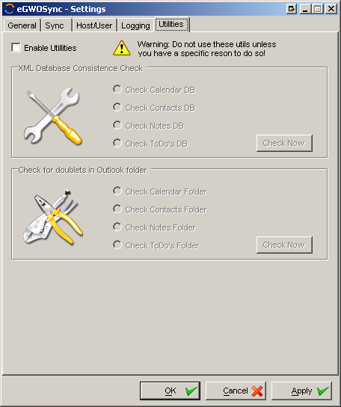
Enable Utilities checkbox will just enable the utilities on this tab page. Please notice that these utilities are only if you have a specific problem and can screw your system even more up that it was before. Make backups before using these utilities!

XML Database Consistense Check is there is problems when loading the xml file. It will detect is any item is in there twice and delete them. It cant correct xml parsing errors, if you fuc.. up your xml file by editing it manually then you are screwed.

Check for Doublets in Outlook Folder will check either calendar, contacts, notes or todo’s folder and see it there are doublets.

Calendar will check “Subject, Body, Start, End, Location and Importance”
Contacts will check “Fullname, Email1address, Title and CompanyName”
Notes will check “Body and subject”
Todo’s will check “Subject, Status, Body and PercentComplete”

If these fields are the same it will detect it as a doublet and delete it. Please notice that this could take a while if it’s a large folder. See the progress in the log window.

Using eGWOSync

Outlook Warnings
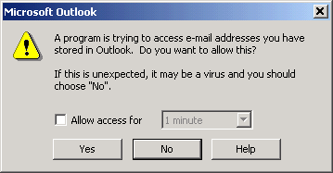
Since Outlook 2000 service pack 3 (I think it was) Microsoft has added a Macro Security, this was to prevent that Viruses and such got access to certain data and functionality in Outlook. This includes access to Calendar, Contact and E-mail items. To still support 3rd party sync tools, they added this (see Error: Reference source not found) warning screen. This is not a fault in eGWOSync, this can’t be helped. You have to either select yes for each item or let eGWOSync access if for either 1, 2, 5 or 10 minutes. The sync will fail if you chose no to this screen!
Figur 1

Tray Icon
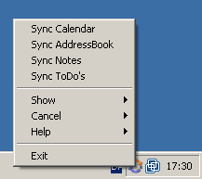
On start up eGWOSync loads into the windows tray icon besides the clock. Here all the features of eGWOSync is available from. You can press Show → Settings to see the settings window, or show → log to see the log window. It pretty much gives it self. :-)

Sync Calendar/Addressbook/Notes/Todo’s
This is where the magic happens. When you press this button, it should sync all you calendar item against eGroupware. Nothing more nothing less. You can see the progress in the from the Show → log button.

See the progress in the log window by clicking show→Log or double click on the tray icon.

Troubleshooting
Some times it doesn’t work as it should; this tool is still in a very early stage and will properly behave very badly many times. These pages will try and help you what to do, when that happens.

Known bugs/Issues

- Calendar doesn’t sync Alarm.
- Calendar YearByNth does not sync to eGroupware (not supported)

TCPTrace
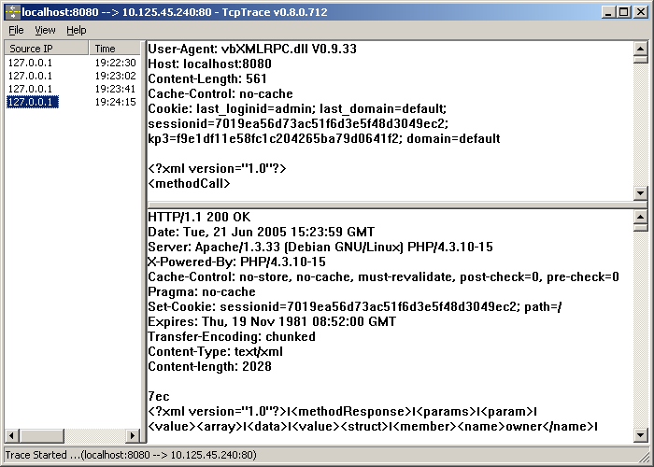
TCPTrace is a proxy server for text based protocols; it’s great for helping debugging errors. It’s programmed by a guy named Simon Fell. It’s free to use by anyone. Thanks Simon…

You can download it here:

http://www.pocketsoap.com/tcptrace/

I have chosen to include Simon’s description and how to use it in this manual, hope he doesn’t mind :-)

Quote http://www.pocketsoap.com/tcptrace/:

Huh, it does what?
Basically you use it as a tunnel between your client & server. Start tcptrace.exe and up comes a dialog box asking for local port #, destination server, and destination port # (Ignore the logging options for now) Fill these in, click Ok, and wow are you going to have fun. For example if you are writing a client and testing against a remote server (say www.razorsoft.net), you can setup

Local Port # 8080
Destination Server www.razorsoft.net
Destination Port # 80

Now configure your client so that it thinks the server is at localhost:8080. tcpTrace will forward all the traffic from localport:8080 to the remote server (and vice versa), dumping the contents in the process. If you are hosting a server say on port 80 and want to use it, then change your server to run on port 81, and setup

Local Port # 80
Destination Server localhost
Destination Port # 81

you can now see your incoming traffic.

It should work with all the text based IP protocols, I've been using it with SOAP (port 80) & HTTP (port 80), and I know Peter Drayton has been using it with POP3 (port 110) & SMTP (port 25)

Quote end.

Looking Into the XML Log
- <?xml version="1.0"?>
- <methodCall>
- <methodName>system.login</methodName>
- <params>
- <param>
- <value>
- <struct>
- <member>
- <name>domain</name>
- <value>
- <string>default</string>
- </value>
- </member>
- <member>
- <name>username</name>
- <value>
- <string>admin</string>
- </value>
- </member>
- <member>
- <name>password</name>
- <value>
- <string>Sup3rC0d3</string>
- </value>
- </member>
- </struct>
- </value>
- </param>
- </params>
- </methodCall>

- <?xml version="1.0"?>
- <methodResponse>
- <params>
- <param>
- <value>
- <struct>
- <member>
- <name>domain</name>
- <value>
- <string>default</string>
- </value>
- </member>
- <member>
- <name>sessionid</name>
- <value>
- <string>5116487361765e7407fed6ff8db47a19</string>
- </value>
- </member>
- <member>
- <name>kp3</name>
- <value>
- <string>d59d9c5787c41cb34dc63899f7a8adc7</string>
- </value>
- </member>
- </struct>
- </value>
- </param>
- </params>
- </methodResponse>

Okay let’s start. Line 1-30 us the request sent to the server and line 31-59 is the response back. This is a simple login request, and it returns our session ID and KP3 ID.

Line1 and 31 defines that this is an xml page version 1.0 nothing there.
Line3 is the method or system call we want eGroupware to execute.
We also send 3 members to eGroupware, one with the domain name, one with the username and one with our password.

All right so far so good. The xml returned to us also contains 3 members witch sends back our domain we are logged in to, our session id and kp3 id. Nothing fancy there.
Please remember that this is a very simple example, and when we transfer a lot of data to and from eGroupware it can quickly be hard to get a overview.

To get further help you can go to eGroupware WIKI site, or the official xmlrpc webpage.

- http://www.egroupware.org/egroupware/wiki/index.php?page=xmlrpc
- http://www.xmlrpc.com

Getting Help

Mailinglists
There is many ways to get help. Properly the best way is either to join the eGroupware developer or user mailing list. Here there are a lot of people that use eGroupware and hopefully also a lot of eGWOSync users. I normally monitor both the user and the developer mailing lists. You can go here to join eGroupware-User mailing list:

- http://lists.sourceforge.net/mailman/listinfo/egroupware-users

And here to join the eGroupware-Developers mailing lists:

- http://lists.sourceforge.net/mailman/listinfo/egroupware-developers

A good idea could be trying to search the mailinglists for subjects and solutions before writing a new email, this can save you time, and will properly save other time reading and writing a reply. You can find the archive for both eGroupware-Developers and User mailing lists here:

- http://sourceforge.net/mail/?group_id=78745

E-mail
Another way is to directly email me. This is okay by me, but if I get so many email that I don’t have time to reply them all, then I properly won’t write back… I will try and help as much as I can. Write to hyber@hyber.dk

FAQ
The third way is the upcoming FAQ site at www.hyber.dk, I will try whenever I have a problem and a solution to update the webpage, so as many people as possible can enjoy the knowledge that other have. If you have something you wish for at the FAQ or homepage, please write to me hyber@hyber.dk

Appendix A

The GNU General Public License (GPL)
Version 2, June 1991
Copyright (C) 1989, 1991 Free Software Foundation, Inc.
59 Temple Place, Suite 330, Boston, MA 02111-1307 USA
Everyone is permitted to copy and distribute verbatim copies
of this license document, but changing it is not allowed.
Preamble
The licenses for most software are designed to take away your freedom to share and change it. By contrast, the GNU General Public License is intended to guarantee your freedom to share and change free software--to make sure the software is free for all its users. This General Public License applies to most of the Free Software Foundation's software and to any other program whose authors commit to using it. (Some other Free Software Foundation software is covered by the GNU Library General Public License instead.) You can apply it to your programs, too.
When we speak of free software, we are referring to freedom, not price. Our General Public Licenses are designed to make sure that you have the freedom to distribute copies of free software (and charge for this service if you wish), that you receive source code or can get it if you want it, that you can change the software or use pieces of it in new free programs; and that you know you can do these things.
To protect your rights, we need to make restrictions that forbid anyone to deny you these rights or to ask you to surrender the rights. These restrictions translate to certain responsibilities for you if you distribute copies of the software, or if you modify it.
For example, if you distribute copies of such a program, whether gratis or for a fee, you must give the recipients all the rights that you have. You must make sure that they, too, receive or can get the source code. And you must show them these terms so they know their rights.
We protect your rights with two steps: (1) copyright the software, and (2) offer you this license which gives you legal permission to copy, distribute and/or modify the software.
Also, for each author's protection and ours, we want to make certain that everyone understands that there is no warranty for this free software. If the software is modified by someone else and passed on, we want its recipients to know that what they have is not the original, so that any problems introduced by others will not reflect on the original authors' reputations.
Finally, any free program is threatened constantly by software patents. We wish to avoid the danger that redistributors of a free program will individually obtain patent licenses, in effect making the program proprietary. To prevent this, we have made it clear that any patent must be licensed for everyone's free use or not licensed at all.
The precise terms and conditions for copying, distribution and modification follow.
TERMS AND CONDITIONS FOR COPYING, DISTRIBUTION AND MODIFICATION
0. This License applies to any program or other work which contains a notice placed by the copyright holder saying it may be distributed under the terms of this General Public License. The "Program", below, refers to any such program or work, and a "work based on the Program" means either the Program or any derivative work under copyright law: that is to say, a work containing the Program or a portion of it, either verbatim or with modifications and/or translated into another language. (Hereinafter, translation is included without limitation in the term "modification".) Each licensee is addressed as "you".
Activities other than copying, distribution and modification are not covered by this License; they are outside its scope. The act of running the Program is not restricted, and the output from the Program is covered only if its contents constitute a work based on the Program (independent of having been made by running the Program). Whether that is true depends on what the Program does.
1. You may copy and distribute verbatim copies of the Program's source code as you receive it, in any medium, provided that you conspicuously and appropriately publish on each copy an appropriate copyright notice and disclaimer of warranty; keep intact all the notices that refer to this License and to the absence of any warranty; and give any other recipients of the Program a copy of this License along with the Program.
You may charge a fee for the physical act of transferring a copy, and you may at your option offer warranty protection in exchange for a fee.
2. You may modify your copy or copies of the Program or any portion of it, thus forming a work based on the Program, and copy and distribute such modifications or work under the terms of Section 1 above, provided that you also meet all of these conditions:
a) You must cause the modified files to carry prominent notices stating that you changed the files and the date of any change.
b) You must cause any work that you distribute or publish, that in whole or in part contains or is derived from the Program or any part thereof, to be licensed as a whole at no charge to all third parties under the terms of this License.
c) If the modified program normally reads commands interactively when run, you must cause it, when started running for such interactive use in the most ordinary way, to print or display an announcement including an appropriate copyright notice and a notice that there is no warranty (or else, saying that you provide a warranty) and that users may redistribute the program under these conditions, and telling the user how to view a copy of this License. (Exception: if the Program itself is interactive but does not normally print such an announcement, your work based on the Program is not required to print an announcement.)
These requirements apply to the modified work as a whole. If identifiable sections of that work are not derived from the Program, and can be reasonably considered independent and separate works in themselves, then this License, and its terms, do not apply to those sections when you distribute them as separate works. But when you distribute the same sections as part of a whole which is a work based on the Program, the distribution of the whole must be on the terms of this License, whose permissions for other licensees extend to the entire whole, and thus to each and every part regardless of who wrote it.
Thus, it is not the intent of this section to claim rights or contest your rights to work written entirely by you; rather, the intent is to exercise the right to control the distribution of derivative or collective works based on the Program.
In addition, mere aggregation of another work not based on the Program with the Program (or with a work based on the Program) on a volume of a storage or distribution medium does not bring the other work under the scope of this License.
3. You may copy and distribute the Program (or a work based on it, under Section 2) in object code or executable form under the terms of Sections 1 and 2 above provided that you also do one of the following:
a) Accompany it with the complete corresponding machine-readable source code, which must be distributed under the terms of Sections 1 and 2 above on a medium customarily used for software interchange; or,
b) Accompany it with a written offer, valid for at least three years, to give any third party, for a charge no more than your cost of physically performing source distribution, a complete machine-readable copy of the corresponding source code, to be distributed under the terms of Sections 1 and 2 above on a medium customarily used for software interchange; or,
c) Accompany it with the information you received as to the offer to distribute corresponding source code. (This alternative is allowed only for noncommercial distribution and only if you received the program in object code or executable form with such an offer, in accord with Subsection b above.)
The source code for a work means the preferred form of the work for making modifications to it. For an executable work, complete source code means all the source code for all modules it contains, plus any associated interface definition files, plus the scripts used to control compilation and installation of the executable. However, as a special exception, the source code distributed need not include anything that is normally distributed (in either source or binary form) with the major components (compiler, kernel, and so on) of the operating system on which the executable runs, unless that component itself accompanies the executable.
If distribution of executable or object code is made by offering access to copy from a designated place, then offering equivalent access to copy the source code from the same place counts as distribution of the source code, even though third parties are not compelled to copy the source along with the object code.
4. You may not copy, modify, sublicense, or distribute the Program except as expressly provided under this License. Any attempt otherwise to copy, modify, sublicense or distribute the Program is void, and will automatically terminate your rights under this License. However, parties who have received copies, or rights, from you under this License will not have their licenses terminated so long as such parties remain in full compliance.
5. You are not required to accept this License, since you have not signed it. However, nothing else grants you permission to modify or distribute the Program or its derivative works. These actions are prohibited by law if you do not accept this License. Therefore, by modifying or distributing the Program (or any work based on the Program), you indicate your acceptance of this License to do so, and all its terms and conditions for copying, distributing or modifying the Program or works based on it.
6. Each time you redistribute the Program (or any work based on the Program), the recipient automatically receives a license from the original licensor to copy, distribute or modify the Program subject to these terms and conditions. You may not impose any further restrictions on the recipients' exercise of the rights granted herein. You are not responsible for enforcing compliance by third parties to this License.
7. If, as a consequence of a court judgment or allegation of patent infringement or for any other reason (not limited to patent issues), conditions are imposed on you (whether by court order, agreement or otherwise) that contradict the conditions of this License, they do not excuse you from the conditions of this License. If you cannot distribute so as to satisfy simultaneously your obligations under this License and any other pertinent obligations, then as a consequence you may not distribute the Program at all. For example, if a patent license would not permit royalty-free redistribution of the Program by all those who receive copies directly or indirectly through you, then the only way you could satisfy both it and this License would be to refrain entirely from distribution of the Program.
If any portion of this section is held invalid or unenforceable under any particular circumstance, the balance of the section is intended to apply and the section as a whole is intended to apply in other circumstances.
It is not the purpose of this section to induce you to infringe any patents or other property right claims or to contest validity of any such claims; this section has the sole purpose of protecting the integrity of the free software distribution system, which is implemented by public license practices. Many people have made generous contributions to the wide range of software distributed through that system in reliance on consistent application of that system; it is up to the author/donor to decide if he or she is willing to distribute software through any other system and a licensee cannot impose that choice.
This section is intended to make thoroughly clear what is believed to be a consequence of the rest of this License.
8. If the distribution and/or use of the Program is restricted in certain countries either by patents or by copyrighted interfaces, the original copyright holder who places the Program under this License may add an explicit geographical distribution limitation excluding those countries, so that distribution is permitted only in or among countries not thus excluded. In such case, this License incorporates the limitation as if written in the body of this License.
9. The Free Software Foundation may publish revised and/or new versions of the General Public License from time to time. Such new versions will be similar in spirit to the present version, but may differ in detail to address new problems or concerns.
Each version is given a distinguishing version number. If the Program specifies a version number of this License which applies to it and "any later version", you have the option of following the terms and conditions either of that version or of any later version published by the Free Software Foundation. If the Program does not specify a version number of this License, you may choose any version ever published by the Free Software Foundation.
10. If you wish to incorporate parts of the Program into other free programs whose distribution conditions are different, write to the author to ask for permission. For software which is copyrighted by the Free Software Foundation, write to the Free Software Foundation; we sometimes make exceptions for this. Our decision will be guided by the two goals of preserving the free status of all derivatives of our free software and of promoting the sharing and reuse of software generally.
NO WARRANTY
11. BECAUSE THE PROGRAM IS LICENSED FREE OF CHARGE, THERE IS NO WARRANTY FOR THE PROGRAM, TO THE EXTENT PERMITTED BY APPLICABLE LAW. EXCEPT WHEN OTHERWISE STATED IN WRITING THE COPYRIGHT HOLDERS AND/OR OTHER PARTIES PROVIDE THE PROGRAM "AS IS" WITHOUT WARRANTY OF ANY KIND, EITHER EXPRESSED OR IMPLIED, INCLUDING, BUT NOT LIMITED TO, THE IMPLIED WARRANTIES OF MERCHANTABILITY AND FITNESS FOR A PARTICULAR PURPOSE. THE ENTIRE RISK AS TO THE QUALITY AND PERFORMANCE OF THE PROGRAM IS WITH YOU. SHOULD THE PROGRAM PROVE DEFECTIVE, YOU ASSUME THE COST OF ALL NECESSARY SERVICING, REPAIR OR CORRECTION.
12. IN NO EVENT UNLESS REQUIRED BY APPLICABLE LAW OR AGREED TO IN WRITING WILL ANY COPYRIGHT HOLDER, OR ANY OTHER PARTY WHO MAY MODIFY AND/OR REDISTRIBUTE THE PROGRAM AS PERMITTED ABOVE, BE LIABLE TO YOU FOR DAMAGES, INCLUDING ANY GENERAL, SPECIAL, INCIDENTAL OR CONSEQUENTIAL DAMAGES ARISING OUT OF THE USE OR INABILITY TO USE THE PROGRAM (INCLUDING BUT NOT LIMITED TO LOSS OF DATA OR DATA BEING RENDERED INACCURATE OR LOSSES SUSTAINED BY YOU OR THIRD PARTIES OR A FAILURE OF THE PROGRAM TO OPERATE WITH ANY OTHER PROGRAMS), EVEN IF SUCH HOLDER OR OTHER PARTY HAS BEEN ADVISED OF THE POSSIBILITY OF SUCH DAMAGES.
END OF TERMS AND CONDITIONS
How to Apply These Terms to Your New Programs
If you develop a new program, and you want it to be of the greatest possible use to the public, the best way to achieve this is to make it free software which everyone can redistribute and change under these terms.
To do so, attach the following notices to the program. It is safest to attach them to the start of each source file to most effectively convey the exclusion of warranty; and each file should have at least the "copyright" line and a pointer to where the full notice is found.
One line to give the program's name and a brief idea of what it does.
Copyright (C) <year> <name of author>
This program is free software; you can redistribute it and/or modify it under the terms of the GNU General Public License as published by the Free Software Foundation; either version 2 of the License, or (at your option) any later version.
This program is distributed in the hope that it will be useful, but WITHOUT ANY WARRANTY; without even the implied warranty of MERCHANTABILITY or FITNESS FOR A PARTICULAR PURPOSE. See the GNU General Public License for more details.
You should have received a copy of the GNU General Public License along with this program; if not, write to the Free Software Foundation, Inc., 59 Temple Place, Suite 330, Boston, MA 02111-1307 USA
Also add information on how to contact you by electronic and paper mail.
If the program is interactive, make it output a short notice like this when it starts in an interactive mode:
Gnomovision version 69, Copyright (C) year name of author Gnomovision comes with ABSOLUTELY NO WARRANTY; for details type `show w'. This is free software, and you are welcome to redistribute it under certain conditions; type `show c' for details.
The hypothetical commands `show w' and `show c' should show the appropriate parts of the General Public License. Of course, the commands you use may be called something other than `show w' and `show c'; they could even be mouse-clicks or menu items--whatever suits your program.
You should also get your employer (if you work as a programmer) or your school, if any, to sign a "copyright disclaimer" for the program, if necessary. Here is a sample; alter the names:
Yoyodyne, Inc., hereby disclaims all copyright interest in the program `Gnomovision' (which makes passes at compilers) written by James Hacker.
signature of Ty Coon, 1 April 1989
Ty Coon, President of Vice
This General Public License does not permit incorporating your program into proprietary programs. If your program is a subroutine library, you may consider it more useful to permit linking proprietary applications with the library. If this is what you want to do, use the GNU Library General Public License instead of this License.

